21.

#include <stdio.h>

#define BS 8

void xor(int *a, int *b, int *r) {
for(int i=0;i<BS;i++)
r[i] = a[i] ^ b[i];
}

void encrypt(int *in, int *key, int *out) {
for(int i=0;i<BS;i++)
out[i] = in[i] ^ key[i];
}

void decrypt(int *in, int *key, int *out) {
for(int i=0;i<BS;i++)
out[i] = in[i] ^ key[i];
}

void print(int *x) {
for(int i=0;i<BS;i++) printf("%d",x[i]);
printf("\n");
}

int main() {
int p[BS], key[BS], iv[BS], temp[BS], c[BS];

printf("Enter 8-bit plaintext: ");
for(int i=0;i<BS;i++) scanf("%1d",&p[i]);
printf("Enter 8-bit key: ");
for(int i=0;i<BS;i++) scanf("%1d",&key[i]);
printf("Enter 8-bit IV: ");
for(int i=0;i<BS;i++) scanf("%1d",&iv[i]);
encrypt(p,key,c);
printf("ECB: ");
print(c);
xor(p,iv,temp);
encrypt(temp,key,c);
printf("CBC: ");
print(c);
/* CFB */
encrypt(iv,key,temp);
xor(p,temp,c);
printf("CFB: ");
print(c);

return 0;
}
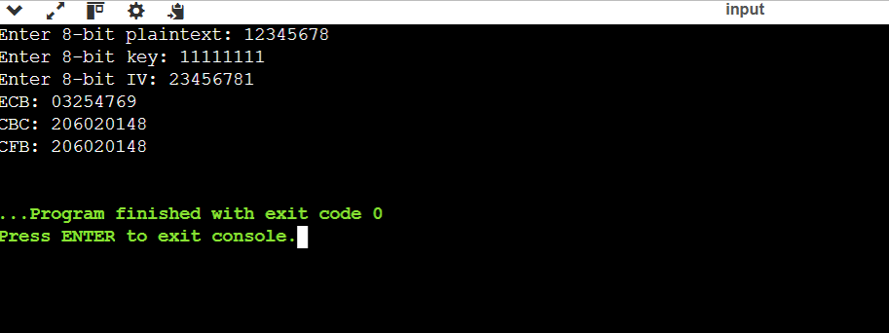

22.
#include <stdio.h>

int sdes(int x, int key) {
/* Simplified S-DES style XOR cipher for CBC demonstration */
return x ^ (key & 255);
}

int main() {
int p[2] = {0x01, 0x23};
int c[2], d[2];
int iv = 0xAA;
int key = 0xFD;

/* CBC Encryption */
c[0] = sdes(p[0] ^ iv, key);
c[1] = sdes(p[1] ^ c[0], key);

printf("Ciphertext: %02X %02X\n", c[0], c[1]);

/* CBC Decryption */
d[0] = sdes(c[0], key) ^ iv;
d[1] = sdes(c[1], key) ^ c[0];

printf("Decrypted: %02X %02X\n", d[0], d[1]);

return 0;
}
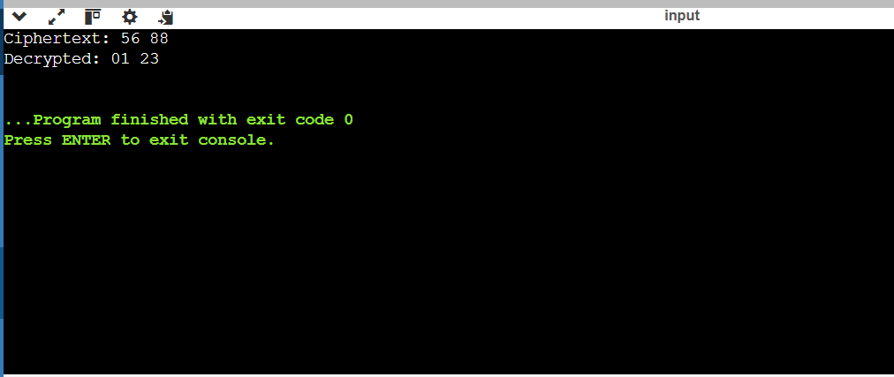

23.
#include <stdio.h>

int sdes(int x, int key) {
return x ^ (key & 255);
}

int main() {
int p[3] = {0x01, 0x02, 0x04};
int c[3];
int counter = 0;
int key = 0xFD;

for(int i=0;i<3;i++) {
c[i] = p[i] ^ sdes(counter++, key);
}

printf("Ciphertext: ");
for(int i=0;i<3;i++)
printf("%02X ",c[i]);

printf("\n");

printf("Decrypted: ");
counter = 0;
for(int i=0;i<3;i++)
printf("%02X ", c[i] ^ sdes(counter++,key));

return 0;
}
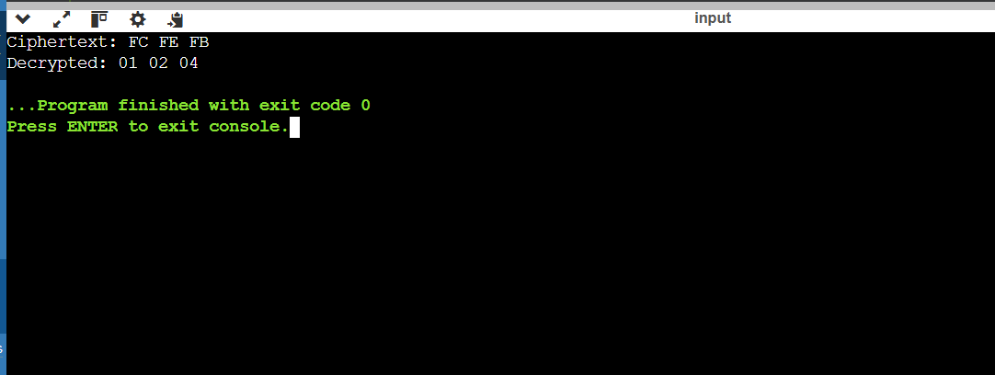

24.
#include <stdio.h>

int main() {
int p = 59, q = 61;
int e = 31;
int phi = (p-1)*(q-1);
int d;

for(d=1; d<phi; d++) {
if((e*d)%phi == 1)
break;
}

printf("p = %d\nq = %d\n",p,q);
printf("phi(n) = %d\n",phi);
printf("Private key d = %d\n",d);

return 0;
}
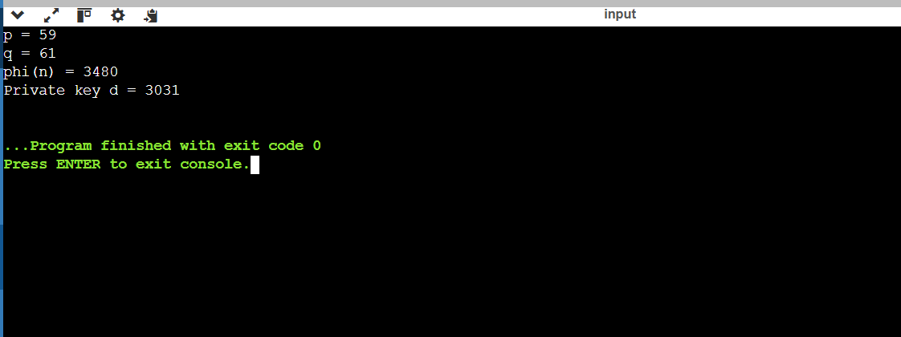

25.

#include <stdio.h>

int gcd(int a,int b) {
while(b) {
int t=a%b;
a=b;
b=t;
}
return a;
}

int main() {
int n,m,g;

printf("Enter n: ");
scanf("%d",&n);

printf("Enter plaintext block: ");
scanf("%d",&m);

g = gcd(m,n);

if(g > 1)
printf("Factor found = %d\nRSA modulus can be factored.\n",g);
else
printf("No factor found.\n");

return 0;
}
